Summer 2013
Final Project Econ 424

Garrett Black

[portfolio Analysis: Vanguard Funds]

Executive Summary

- Background: The S&P 500 (VFINX), the European Stock Exchange (VEURX), An emerging Markets Fund (VEIEX), Long and Short-Term Bonds (VBLTX and VBISX), and the MSCI Pacific index (VPACX) were analyzed in order to produce risk and return estimates in conjunction with portfolio recommendations.
- method: through convex combinations of various minimum variance and tangency portfolios, while targeting certain returns, several different efficient portfolios were achieved. estimated returns, along with standard error predictions, were also produced. monthly historical prices and returns from may 2008 to may 2013 were also utilized as comparisons, with 60 data points overall.
- Results: overall, the safest assets in which to invest were primarily vbisx, with vbltx a distant second. however, to achieve target returns, it was best to short sell veiex, veurx, and vpacx, while investing in vfinx to an extent, and reserving some funds in vbisx for security.

Table of Contents:

- Return Calculations and Plots
- Sample Statistics
- Value-at-Risk Calculations
- Rolling CER Parameter Analysis
- Portfolio Theory
- Asset Allocation
- Single Index and CAPM

1. Return Calculations and Plots
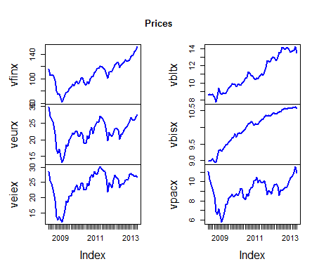
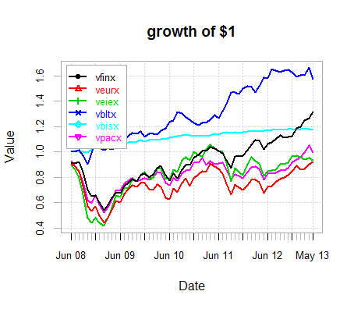
VBLTX gives the highest future value, which isn’t quite surprising, since people would have bought plenty of bonds in the wake of the financial crisis, seeking safer returns. VEURX’s returns seem rather small, along with VEIEX. VFINX’s returns contrast, seeming pretty sizable. The sizable dip in all indices is obviously the 2008 crisis, with corresponding recoveries. The various European PIIGS’ crises probably led to its various dips and bends, with corresponding dips in VEIEX. VPACX would go along with VEIEX, since many emerging economies are tied to China’s vast consumption of raw materials. Whereas the recovery of corporations overall would lead to the VFINX climbing. The bond returns are most likely explained by flaps in the market and expectation of rising interest rates. VBISX and VBLTX have a few outliers on the positive side, probably spiked by the 2008 crisis. All the stocks have negative 2008 outliers as well.
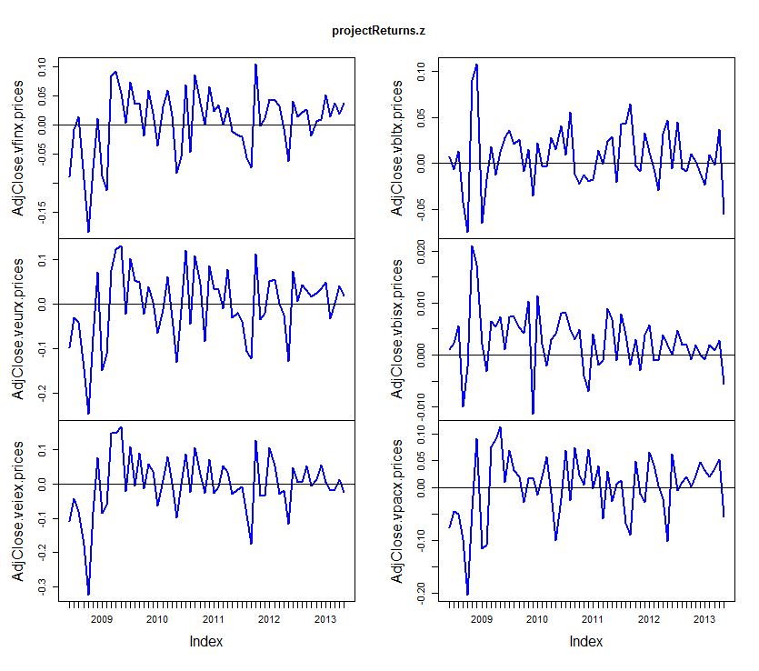
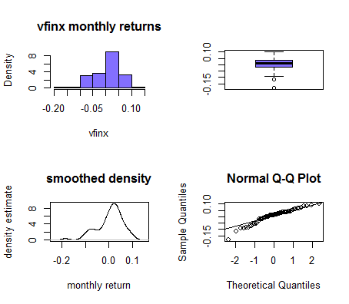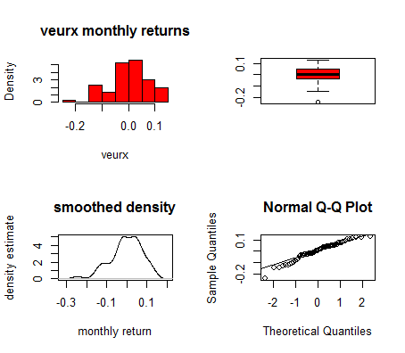
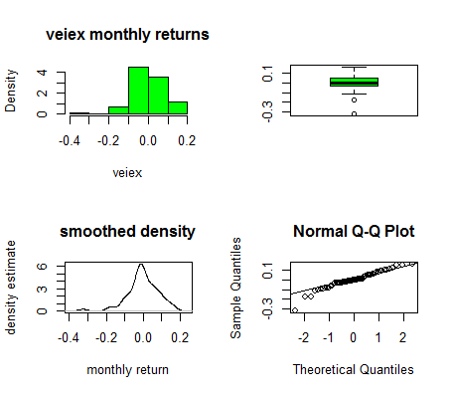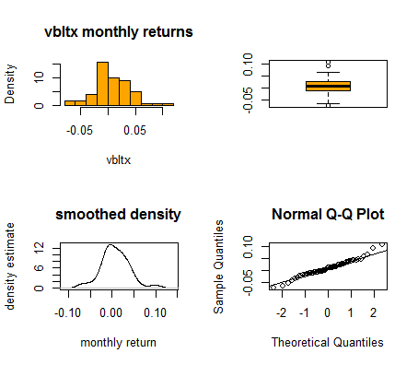
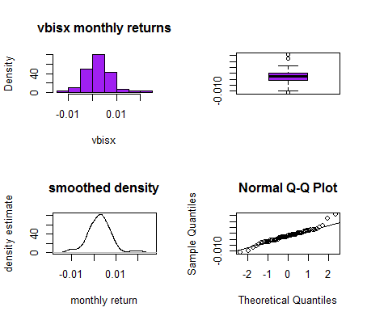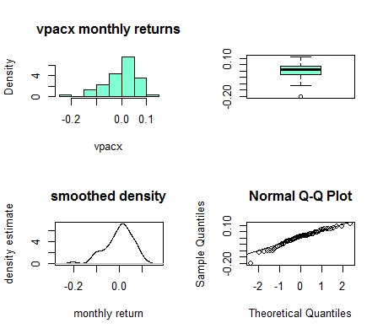

2. Descriptive/Sample Statistics
Index | Mean | St.Dev | Excess Kurtosis | Sharpe Slopes | Skew | Variance | 1% Quantile | 5% Quantile
vfinx | 0.00457 | 0.05550 | 1.00847 | 0.07483 | -.90382 | 0.00308 | -0.14185 | -0.08852
veurx | -0.0014 | 0.07760 | 0.36904 | -0.0235 | -.63236 | 0.00602 | -0.18751 | -0.13116
veiex | -0.0012 | 0.08504 | 2.34631 | -0.0191 | -.83375 | 0.00723 | -0.23748 | -0.12043
vbltx | 0.00756 | 0.03296 | 1.06735 | 0.21674 | 0.28229 | 0.00109 | -0.06889 | -0.04298
vbisx | 0.00269 | 0.00549 | 1.88930 | 0.41300 | 0.40662 | 0.00003 | -0.01051 | -0.00573
vpacx | -0.0001 | 0.06103 | 0.78072 | -0.0091 | -.77352 | 0.00372 | -0.15220 | -0.10309

VBLTX has the highest average return while VEURX limps behind at the lowest average return (has the greatest negative number, so lowest return). VEIEX has a pretty high standard deviation, the highest as a matter of fact, while VBISX is quite low. VBISX also has the highest Sharpe’s slope, meaning it has the best return-risk ratio. VBLTX looks fairly normally distributed, but VBISX has the lowest variance. Consulting the graphs below, it’s easier to see that VBLTX and VBISX are closest to normal distributions, but still have enough skew and variance they don’t quite fit.
Standard Errors

 | muhat.vals | se.muhat | sigmahat | se.sigmahat | sigma2hat. | se.sigma2hat
vfinx | 0.00457 | 0.00716 | 0.05550 | 0.00507 | 0.00308 | 0.00056
veurx | -0.00141 | 0.01002 | 0.07760 | 0.00708 | 0.00602 | 0.00110
veiex | -0.00121 | 0.01098 | 0.08504 | 0.00776 | 0.00723 | 0.00132
vbltx | 0.00756 | 0.00426 | 0.03296 | 0.00301 | 0.00109 | 0.00020
vbisx | 0.00269 | 0.00071 | 0.00549 | 0.00050 | 0.00003 | 0.00001
vpacx | -0.00014 | 0.00788 | 0.06103 | 0.00557 | 0.00372 | 0.00068
VBISX far and away has the smallest standard error; the other estimations are decent, except for VEURX and VEIEX. The estimated numbers are more accurate than the actual standard deviations.
Confidence Intervals

 | vfinx | veurx | veiex | vbltx | vbisx | vpacx
mu.lower | -0.00976 | -0.02144 | -0.02316 | -0.00095 | 0.00127 | -0.01589
mu.upper | 0.01890 | 0.01863 | 0.02075 | 0.01607 | 0.00410 | 0.01562
sigma.lower | 0.04536 | 0.06343 | 0.06951 | 0.02695 | 0.00449 | 0.04988
sigma.upper | 0.06563 | 0.09176 | 0.10057 | 0.03898 | 0.00650 | 0.07217
sigma2.lower | 0.00196 | 0.00382 | 0.00459 | 0.00069 | 0.00002 | 0.00236
sigma2.upper | 0.00420 | 0.00822 | 0.00987 | 0.00148 | 0.00004 | 0.00508
Given that all the indices except VBISX cross 0, there’s a fair amount of uncertainty in all but VBISX. And accordingly, VBISX has the most exact intervals.
Annual Statistics

 | Annual St.Dev of Return | Annual Mean Return | $1 Growth in 5 Yrs.
vfinx | 0.19225 | 0.05483 | 1.315412099
veurx | 0.26881 | -0.01691 | 0.918925708
veiex | 0.29459 | -0.01449 | 0.930112251
vbltx | 0.11419 | 0.09074 | 1.574125689
vbisx | 0.01903 | 0.03223 | 1.174861185
vpacx | 0.21140 | -0.00164 | 0.991833528
The annual returns reflect some interesting points. Namely, VBLTX appears to be the highest-returning fund, while the S&P 500 is no slouch either. $1 would grow similarly to the calculations above.
Pairwise Plots
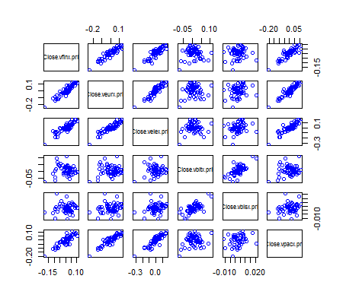
VFINX, VEURX, VEIEX and VPACX appear fairly related, with the strongest relationship between VFINX and VEURX. This all makes sense; the S&P 500 and European markets would intertwine due to trade concerns, while corporations rely on emerging markets for raw materials, as well as the VPACX producers. Meanwhile, the bond markets would be only slightly related.
Covariance
Asset | vfinx | veurx | veiex | vbltx | vbisx | vpacx
vfinx | 0.00308 | 0.00397 | 0.00411 | 0.00001 | 0.00003 | 0.00297
veurx | 0.00397 | 0.00602 | 0.00606 | 0.00023 | 0.00009 | 0.00437
veiex | 0.00411 | 0.00606 | 0.00723 | 0.00034 | 0.00011 | 0.00464
vbltx | 0.00001 | 0.00023 | 0.00034 | 0.00109 | 0.00012 | 0.00038
vbisx | 0.00003 | 0.00009 | 0.00011 | 0.00012 | 0.00003 | 0.00008
vpacx | 0.00297 | 0.00437 | 0.00464 | 0.00038 | 0.00008 | 0.00372
Correlation
Asset | vfinx | veurx | veiex | vbltx | vbisx | vpacx
vfinx | 1.0000 | 0.9227 | 0.8705 | 0.0032 | 0.0885 | 0.8781
veurx | 0.9227 | 1.0000 | 0.9190 | 0.0916 | 0.2098 | 0.9235
veiex | 0.8705 | 0.9190 | 1.0000 | 0.1226 | 0.2260 | 0.8934
vbltx | 0.0032 | 0.0916 | 0.1226 | 1.0000 | 0.6797 | 0.1881
vbisx | 0.0885 | 0.2098 | 0.2260 | 0.6797 | 1.0000 | 0.2277
vpacx | 0.8781 | 0.9235 | 0.8934 | 0.1881 | 0.2277 | 1.0000

As seen above, VFINX, VEURX, VEIEX, and VPACX are strongly correlated, with VFINX and VEURX most strongly correlated. VBLTX is barely correlated with anything apart from VBISX. It appears that VEIEX and VPACX covary together quite well, as do VEURX with VFINX, and VEIEX with VFINX. Overall, moving between asset types appears to produce the lack of correlation.
Asset | RhoHats | RhoHat SEs | Upper Rho - 95% | Lower Rho - 95%
VFINX,VEURX | 0.922745 | 0.019177 | 0.961098 | 0.884391
VFINX,VEIEX | 0.870545 | 0.031262 | 0.933068 | 0.808022
VFINX,VBLTX | 0.003250 | 0.129098 | 0.261446 | -0.254946
VFINX,VBISX | 0.088483 | 0.128089 | 0.344660 | -0.167694
VFINX,VPACX | 0.878141 | 0.029547 | 0.937234 | 0.819047
VEURX,VEIEX | 0.919011 | 0.020065 | 0.959140 | 0.878881
VEURX,BLTX | 0.091579 | 0.128017 | 0.347612 | -0.164455
VEURX,VBISX | 0.209822 | 0.123416 | 0.456653 | -0.037010
VEURX,PACX | 0.923510 | 0.018994 | 0.961499 | 0.885521
VEIEX,VBLTX | 0.122612 | 0.127159 | 0.376929 | -0.131705
VEIEX,VBISX | 0.225996 | 0.122506 | 0.471008 | -0.019016
VEIEX,VPACX | 0.893430 | 0.026050 | 0.945530 | 0.841330
VBLTX,VBISX | 0.679717 | 0.069454 | 0.818624 | 0.540810
VBLTX,VPACS | 0.188079 | 0.124533 | 0.437145 | -0.060986
VBISX,VPACX | 0.227703 | 0.122406 | 0.472515 | -0.017108

Given the standard errors on the correlation values, the estimates are more precise within an asset type. As for the diversification, since the correlation appears to be fairly weak in many instances, spreading across various assets could improve matters, yet since these portfolios already seem fairly diversified, there may not be much more benefit to reap.

3. Value-at-Risk Calculations

Monthly VaRs

Asset | VaR.01 | VaR.05
vfinx | -11709.2756 | -8306.116711
veurx | -16633.84908 | -12106.60283
veiex | -18048.50303 | -13158.67466
vbltx | -6679.129948 | -4558.915355
vbisx | -1004.297974 | -633.0020729
vpacx | -13246.79733 | -9562.790481
VBISX has lowest VaR, while VEIEX dominates the risk overall at both 1% and 5%.
Annual VaRs

Asset | Annual St.Dev | Annual Mean Return | VaR.05.annual | VaR.01.annual
vfinx | 0.19225 | 0.05483 | -23002.18811 | -32457.31401
veurx | 0.26881 | -0.01691 | -36812.46932 | -47389.55995
veiex | 0.29459 | -0.01449 | -39289.13688 | -50331.97685
vbltx | 0.11419 | 0.09074 | -9252.192985 | -16046.37963
vbisx | 0.01903 | 0.03223 | 92.8859503 | -1196.820684
vpacx | 0.2114 | -0.00164 | -29486.22714 | -38947.12947
VEIEX still is the highest-risk component, while VBISX still resolutely stays low.

Empirical Value-at-Risk Calculations
Asset | Means | St.Dev | VaR.05 | VaR.01 | VaR.05.Annual | VaR.01.Annual
VFINX | 0.0548 | 0.1922 | -81313.5604 | -92852.3208 | -23001.5550 | -32456.5724
VEURX | -0.0169 | 0.2688 | -81215.3343 | -90912.8025 | -36811.7676 | -47388.8354
VEIEX | -0.0145 | 0.2946 | -75388.7104 | -93785.9262 | -39289.1531 | -50332.0305
VBLTX | 0.0907 | 0.1142 | -78416.4822 | -90164.7728 | -9253.0834 | -16047.4159
VBISX | 0.0322 | 0.0190 | -78405.5742 | -90953.2912 | 92.5480 | -1197.0966
VPACX | -0.0016 | 0.2114 | -81493.4837 | -91724.4910 | -29485.9112 | -38946.7830

The empirical results equalize the risk between all the stock indices much more; the numbers are much closer together. VBISX, of course, stays quite low. Thus, using the empirical results, we see how the differences in reality are not quite as vast as prior numbers would have us believe.
Boot Statistics

 | BootStrap |  |  | 95% Level
 | Original | Bias | Standard Error | Normal | Percentile
vfinx | -8306.117 | 195.0595 | 1372.952 | (-11191, -5809) | (-10794, -5396)
veurx | -12106.6 | 117.0513 | 1670.458 | (-15498, -8950) | (-15224, -8667)
veiex | -13158.67 | 62.939222 | 2198.795 | (-17531, -8912) | (-17550, -8967)
vbltx | -4558.915 | 65.85308 | 652.6469 | (-5904, -3346) | (-5757, -3187)
vbisx | -633.0021 | 16.56643 | 114.852 | (-874.7, -424.5) | (-845.9, -391.4)
vpacx | -9562.79 | 174.6323 | 1434.159 | (-12548, -6927) | (-12157, -6637)
The standard errors bear out my conclusions somewhat thus far; VBISX still offers the safest bet, whereas the high errors for VEIEX and VEURX may imply the errors are overstated, somewhat. Overall, the estimates are somewhat precise; the errors seem to hover too high for my liking.

4. Rolling Analysis of the CER Model Parameters
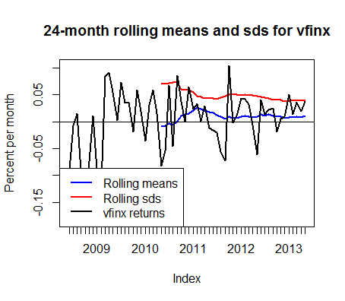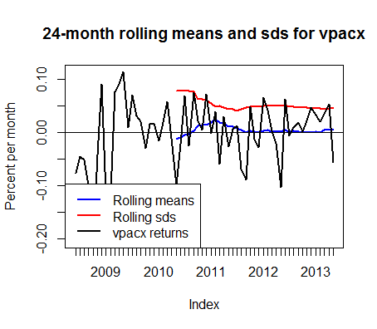

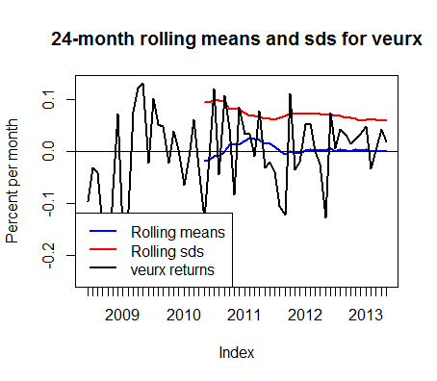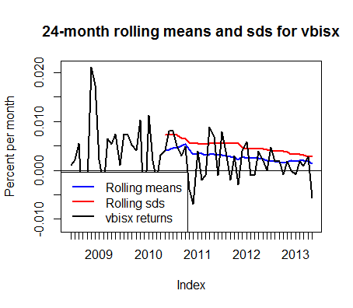
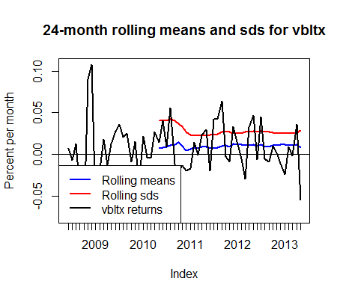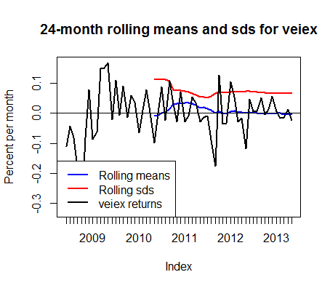
Overall, after some odd jumps or humps in the first half of 2011 (with escalating European crises rippling worldwide), the means and standard deviations stabilize somewhat, mostly. They continue on their slight upward or downward trends, depending on the index. Tables for the numerical values are in an appendix.

5. Portfolio Theory

Portfolio | Expected Return | Standard Deviation | Variance  (E-05) | Annualized Return | Annualized SD | Sharpe’s Ratio
Global Minimum | 0.0024980 | 0.0042254 | 1.78544 | 0.0299754 | 0.0146374 | 0.4925583
Global Min. No Shorts | 0.0026874 | 0.0054929 | 3.01723 | 0.0322489 | 0.0190281 | 0.4133927
Efficient (Target Max Ret) | 0.0075614 | 0.0160425 | 25.7363 | 0.0907362 | 0.0555730 | 0.4453568
Tangency | 0.0034162 | 0.0050727 | 2.57321 | 0.0409949 | 0.0175723 | 0.5913124
Tangency  No Shorts | 0.0027028 | 0.0055116 | 3.03773 | 0.0324340 | 0.0190927 | 0.414795
With short sales, expected return went up for tangency and declined for global minimum. Tangency with shorts also improved in Sharpe’s ratio compared to that without shorts. Sharpe’s ratio for each asset under the tangency portfolio showed that VBISX had the highest Sharpe’s ratio as well, if you compare it to that above.

Global Minimum With Short Sales and Without Weights
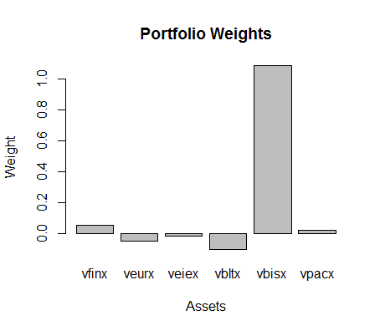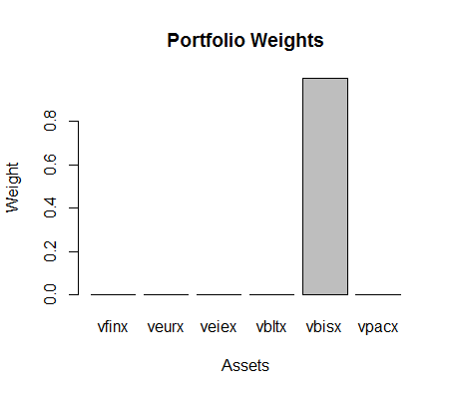
So with short sales, there are some negative weights, meaning that VEURX, VBLTX, and VEIEX will be shorted slightly, in this global minimum variance portfolio. Without the option of short sales, VBISX becomes our safest bet.
Tangency Portfolio Weights With Short Sales and Without
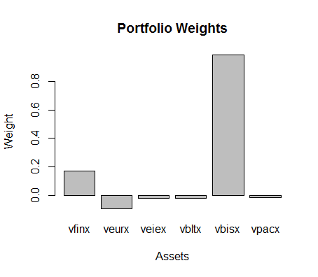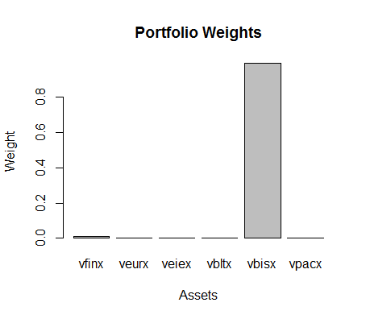
Again, some negative weights, so shorting of VEURX primarily combined with shorting of VPACX, VBLTX, and VEIEX.

Efficient Portfolio Max
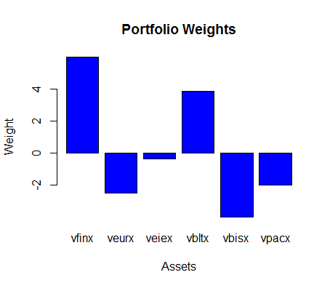
Value-at-Risk Calculations

 | VaR.01.simple | VaR.05.simple | GminPort .01 | GminPort.05 | GminPortNS.01 | GminPortNS.05
vfinx | -11374.48 | -8019.79 | -640.38 | -451.51 | -11.37 | -8.02
veurx | -16071.29 | -11612.23 | 750.53 | 542.29 | 0.00 | 0.00
veiex | -17316.60 | -12521.89 | 264.94 | 191.58 | 0.00 | 0.00
vbltx | -6721.79 | -4573.87 | 666.80 | 453.73 | 0.00 | 0.00
vbisx | -1007.32 | -634.61 | -1091.23 | -687.47 | -1006.31 | -633.98
vpacx | -12838.65 | -9214.19 | -277.31 | -199.03 | 0.00 | 0.00
The global minimum portfolio values, compared to those for individual assets, are quite low.
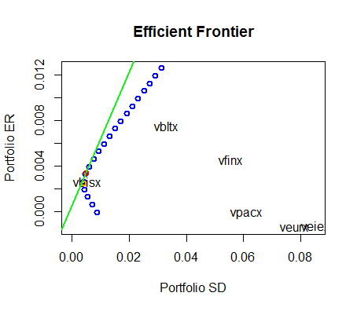
(red dot is tangency portfolio, orange dot is global min, names indicate approximate location)

6. Asset Allocation
Efficient Portfolio with No Short Sales Metrics and Monthly Target Return of .5%
Asset | VaR.01 | VaR.05 | EF.Port.Weights | St.Dev
vfinx | 7454.774553 | -177.446974 | 7.72% | 0.01717699
veurx | 0 | 0 | 0 | Expected Return
veiex | 0 | 0 | 0 | 0.5%
vbltx | 42961.51812 | -1022.618636 | 44.49%
vbisx | 46148.14454 | -1098.470322 | 47.79%
vpacx | 0 | 0 | 0

Tangency and T-Bills Portfolio
Tangency and T-Bills Portfolio with No Short Sales and Monthly Target Return of 0.5%
Asset | VaR.01 | VaR.05 | EF.Port.Weights | StDev
vfinx | -51.32997049 | -37.77924347 | 1.84% | 0.01104972
veurx | 0 | 0 | 0 | Expected Return
veiex | 0 | 0 | 0 | 0.50%
vbltx | 0 | 0 | 0.00% | T-Bills Allocation
vbisx | -5528.014648 | -4068.660265 | 198.64% | -1.004824
vpacx | 0 | 0 | 0 | -$100482.4

The values at risk of these portfolios are much smaller than the other VaRs calculated above. The risk is quite diminished.

7. Single Index Model and CAPM

Asset | Beta | Alpha | Residual SE | Multiple R^2
VEURX | 1.290219 | -0.007304 | 0.03016 | 0.8515
SE | 0.003908 | 0.070761
VEIEX | 1.333994 | -0.007303 | 0.04221 | 0.7578
SE | 0.005468 | 0.099013
VBLTX | 0.00193 | 0.007553 | 0.03225 | 0.00001056
SE | 0.004307 | 0.077995
VBISX | 0.0087583 | 0.0026454 | 0.005519 | 0.007829
SE | 0.0007149 | 0.0129462
VPACX | 0.965625 | -0.004549 | 0.02945 | 0.7711
SE | 0.003814 | 0.069075

It appears that VEURX, VEIEX, and VPACX are all very market responsive, according to the Betas, while they are also responsible for most the market share. The estimates are not exactly that precise, however, averaging nearly 10% off. The bonds are least responsive and don’t have much market share at all. None of this is surprising; stocks make up more of the market usually.

Asset | Confidence Intervals | Intercept | VFINX
VEURX | 2.5% | -0.01513 | 1.14858
 | 97.5% | 0.00052 | 1.43186
VEIEX | 2.5% | -0.01825 | 1.13580
 | 97.5% | 0.00364 | 1.53219
VBLTX | 2.5% | -0.00107 | -0.15419
 | 97.5% | 0.01617 | 0.15806
VBISX | 2.5% | 0.00121 | -0.01716
 | 97.5% | 0.00408 | 0.03467
VPACX | 2.5% | -0.01218 | 0.82736
 | 97.5% | 0.00309 | 1.10389

Simply by using the confidence intervals above, the hypothesis that Beta is = 1 can be rejected at the 95% level for nearly every fund except VPACX.
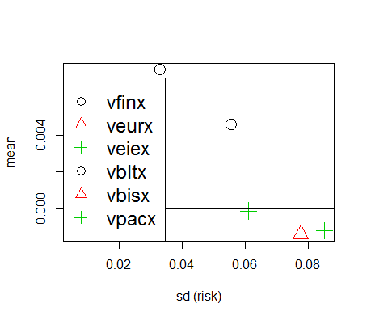
There’d appear to be no linear relationship between the means and the standard deviations, however, a least squares regression could produce a linear result, possibly.

Global Min. Variance Beta
Asset | Weight | Beta | Beta.port
vfinx | 5.63% | 1 | 0.0563
veurx | -4.67% | 1.290219 | -0.060253227
veiex | -1.53% | 1.333994 | -0.020410108
vbltx | -9.92% | 0.00193 | -0.000191456
vbisx | 108.33% | 0.0087583 | 0.009487866
vpacx | 2.16% | 0.965625 | 0.0208575
 |  | Portfolio.Beta | 0.000965096
Tangency Portfolio Beta
Asset | Weight | Beta | Beta.port
vfinx | 0.17% | 1 | 0.001707
veurx | -0.09% | 1.290219 | -0.001208935
veiex | -0.02% | 1.333994 | -0.000297481
vbltx | -0.02% | 0.00193 | -4.4004E-07
vbisx | 0.99% | 0.0087583 | 8.63393E-05
vpacx | -0.02% | 0.965625 | -0.000170916
 |  | Portfolio.Beta | 1.92613E-05
As we can see from above, the portfolios minimized the beta responsiveness to the market; even though VFINX still was responsive, particularly in the minimum variance portfolio, overall the betas were quite diminished.

